Village of Pesotum
  - Volume 1 / Issue 1 / November, 2024
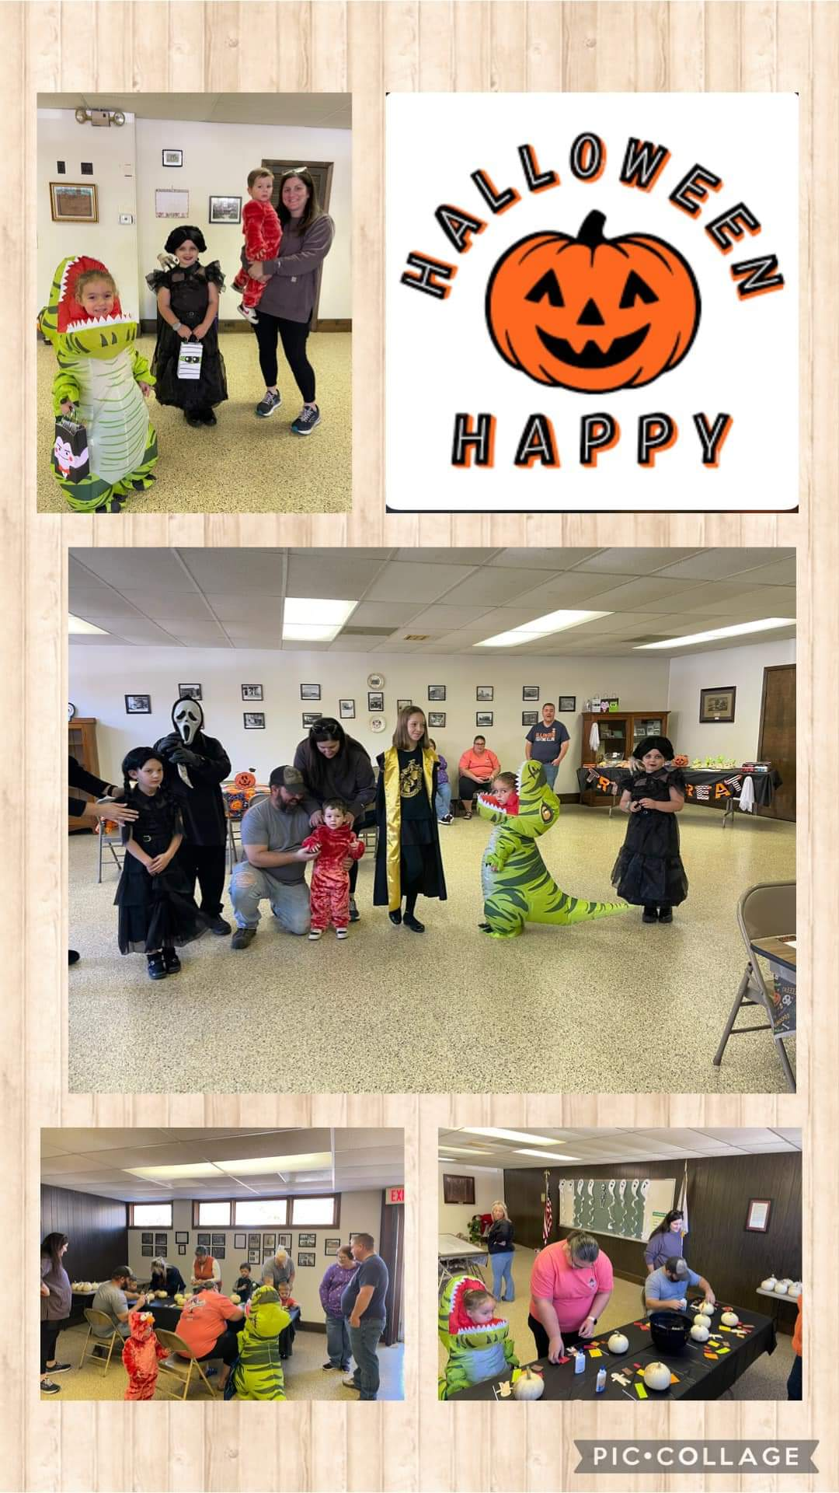
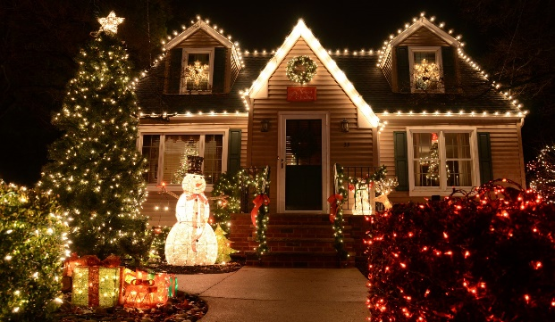
Tap here to add a caption

VILLAGE HALLOWEEN PARTY
Thank you to everyone who came out to join us for the annual village Halloween party. It was so much fun seeing the kids in their costumes. We would like to give a huge thank you to the Sons of the American Legion for their generous donation, which made this event possible.



Holiday tree lighting event
Sunday, December 8, 2024, from 2:00 p.m. to 4:00 p.m.
Festivities to include: An opportunity for children to make ornaments from pinecones for the Christmas tree
Carriage rides from Merrybeth Farm Carriage Service
Beverages from Travelin’ Tom’s Coffee Truck

light up pesotum contest
Win a $50 gift certificate to Wayside 45 by decorating your home/yard for the holidays. The winner will be announced Saturday,
December 21.
Thank you for being a caring community every day and for making Pesotum a beautiful village for the holidays!

Open Positions on the Village Board of Trustees


Contact Us
Village of Pesotum
103 E. Lincoln St.
P.O. Box 200
Pesotum, IL 61863-0200
Phone (217) 493-0208
Email: clerk@pesotum.org
Website: www.pesotum.org
Village of Pesotum  103 E. Lincoln St.  P.O. Box 200  Pesotum, IL 61863-0200 | PRSRT STD  ECRWSS  U.S.POSTAGE  PAID  EDDM Retail
Resident
Pesotum, IL 61863

If you would like to become more involved in your community and local government, there is an immediate opening for a seat on the Village Board of Trustees. Submit a letter of interest to the Village President if you are interested in filing this unexpired term, which will be up for re-election at the next municipal election in April of 2025.
At the next municipal election in April 2025, there will be four (4) open seats. There will be three (3) seats for Village trustee, each with a 4-year term. In addition, the Village President position will be open. Caucuses for the upcoming election will be held December 2, 2024. If you are interested in one of these open seats, plan to attend the Caucuses. Please reach out to Joyce Ragle or an existing member of the Board of Trustees if you are interested in any of these opportunities.

Chapter 12. open burning - An excerpt FROM ORDINANCES and Resolutions
No person shall cause or allow open burning of agricultural waste, garbage, refuse, domicile waste or trade waste. The open burning of landscape waste shall be permitted, but only on the premises on which such waste is generated; and when atmospheric conditions will readily dissipate contaminants.
Landscape waste includes trees, tree trimmings, branches, stumps, brush, weeds, leaves, and shrubbery. The burning of fuels for legitimate campfire, recreational and cooking purposes, or in domestic fireplaces, in such areas where burning is consistent with other laws, provided that no garbage shall be burned in such cases.

